A Quick Guide to creating a Panopto Recording for Non-Faculty and Staff

Device Requirements:
• A Mac or PC
• An Internet connection
• The Panopto client
• A microphone on your computer
• Lecture material

Download the software click the link below.
https://www.technology.pitt.edu/services/pitt-video-panopto

To Begin Your Recording:
- Open your PowerPoint slides
- Launch the software and login to Pitt Passport/DUO. If you cannot login to the Pitt Passport or do not have access, please let Matt Freidhoff or TJ Pile know
- Give you recording a name
- Ensure your microphone is working. You will see the dial turn green if your microphone is on.
• Give your recording a name
• Good idea to use the course title and then a lecture date.
• Make sure your microphone is selected
• Click the box to capture your PowerPoint
- Click the big Red Button Record to begin your recording
- Give your recording a folder to save to

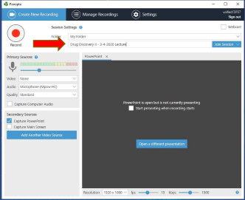

Once you have finished your recording:

- Stop your recording by clicking the recording by again clicking the Big Red Button
• That way, course folders can be shared with students and they automatically gain access to new content saved into them.
• Matt Freidhoff and T.J. Pile can assist you with your video organization.
• Panopto will begin uploading your video to the server. Normally compiling and rendering time is about 5 to 10 minutes, though can be longer. (Be patient; the upload time is variable due to Internet speed, presentation length, computer speed, and server congestion that all play a role in the upload time.)

Settings and sharing your video or videos
Panopto has several settings which will be located on the left side of the screen and you have the ability to change these settings. The most important of these settings is Sharing and with the share settings, there are 6 settings. For sharing a video, the most common settings are Unlisted and noted below.

•You now have the ability to change the settings of your video including permissions, viewable times, name, and etc.
•Click the “Share” button to be taken to the Panopto page for your video.

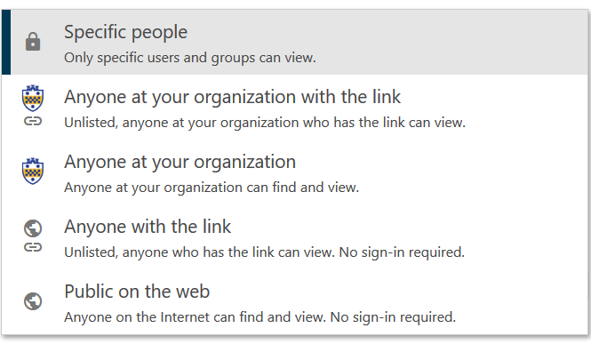
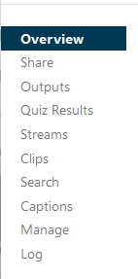

Panopto Resources:
Panopto Video Tutoriales: https://howtovideos.hosted.panopto.com/Panopto/Pages/Folders/DepartmentHome.aspx?folderID=4b9de7ae-0080-4158-8496-a9ba01692c2e
Panopto Documentation:
https://support.panopto.com/s/topic/0TO390000003VN8GAM/getting-started
Pitt IT Panopto Resources: https://www.technology.pitt.edu/services/pitt-video-panopto

